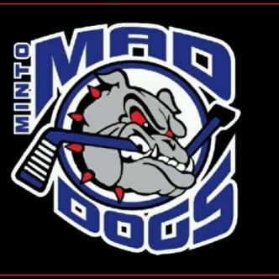

Minto Minor Hockey Association
2015-2016 Season

Dear Junior / Senior Development Hockey Family:

Welcome to the Minto Minor Hockey Association! We hope that this year will be the beginning of many years with our minor hockey family. The Minto Minor Hockey Executive wanted to make you aware of a few things that will hopefully help make this a very successful season for your son or daughter.

Every Minto Minor Hockey player, including those in our development system must wear full equipment, this includes the following:
- CSA approved helmet with face mask
- Mouth guard
- Neck guard
- Hockey pants, chest protector, elbow pad, shin pads
- Jock or Jill
- Gloves
- Skates
- Stick

All players in the development system will have the opportunity to try all positions including goalie. Minto Minor Hockey provides these teams with goalie equipment. Minto Minor Hockey jerseys will be supplied if your child’s team plays a game. Practice jerseys of any colour are allowed for regular ice time.

In order to develop our new players for future successful hockey seasons with Minto our development program enables Junior Development and Senior Development kids to have three (3) ice times each week. Please expect ice times in both the Palmerston and Harriston arenas weekly. The development program is such that the main focus is on skating and hockey skills development. You can expect some inner squad hockey games but games against other centers do not generally occur until after Christmas.

Finally, our hockey system could not run and would not be successful without the help of countless volunteers. We ask that every family get involved in the minor hockey system. You may volunteer as a part of the bench staff. This requires Speak Out Program PRS completion. This can be done online through the OMHA (Ontario Minor Hockey Association). You can also volunteer to help with the annual Junior and Senior Development tournaments. These are already booked: JD February 27th, 2016 and SD March 5th, 2016. In Minto we run tournaments for all hockey levels. In the past our tournaments have been well attended and thus successful. This allows us to keep other fundraising during the hockey system to a minimum. Your team will need the following:
- Tournament Convener
- Food Convener
- Time Clock keeper(s)
- Prize Table organizer(s)
*only to name a few*
Please mark the tournament date(s) on your calendar and plan on being available for the entire day(s).

Please make yourself familiar with the Minto Minor Hockey website, http://mintominorhockey.ca/. We are in the habit of making updates to items and hockey schedules on a very regular basis. You can also sign up for electronic schedule change notifications to stay better informed about everything hockey in Minto through the website.

Again, welcome to Minto Minor Hockey. Feel free to contact any member of the executive at any time with questions.

Yours in Hockey,

Nikki Lobsinger
Secretary for Minto Minor Hockey

